Heat Exchanger Laboratory

- Introduction

A device used to implement heat exchange between two fluids that are at different temperature and separated by a solid wall is termed a heat exchanger. It is widely used in space heating and air-conditioning, power production, refrigeration systems, waste heat recovery, and chemical processing.

Heat exchangers are typically classified according to flow arrangement and type of construction. The simplest heat exchanger is one for which the hot and cold fluids move in the same or opposite directions in a concentric tube (or double pipe) construction. In the parallel-flow (concurrent flow) arrangement, the hot and cold fluids enter at the same end, flow in the same direction, and leave at the same end. In the counter-flow (counter-current) arrangement, the fluids enter at opposite ends, flow in opposite directions, and leave at opposite ends. Alternatively, the fluids may move in cross flow (perpendicular to each other), fluids moving over the tubes can be either mixed or unmixed. Another common configuration is the shell-and-tube heat exchanger. Specific forms differ according to the number of shell-and-tube passes. Baffles are usually installed to increase the convection coefficient of the shell-side fluid by inducing turbulence and a cross-flow velocity component. More information about heat exchanger can be found in Chapter 11.1 of “Fundamentals of Heat and Mass Transfer” (Frank P. Incropera and David P. DeWitt).

The objectives of this lab are:
- To determine the overall heat transfer coefficient and the heat transfer coefficients inside and outside the tube.
- To investigate the relationship between Nusselt number and Reynolds number for turbulent flow through a circular pipe.
- And to compare parallel and counter-flow in a heat exchanger.

- Laboratory Information

The heat exchanger used for this lab is of the double pipe type, with hot water flowing through the central tube while cooling water flows through the annular space. It can be operated in either counter or parallel flow.

The apparatus allows control of the inlet temperature T_{hot}, the hot water flow rate m_{hot}, the cold water flow rate m_{cold}, and arrangement of the heat exchanger (i.e. either parallel or counter flow). The temperature can be measured at ten locations within the heat exchanger, with the locations listed in Section 2.1. The dimensions for the apparatus are listed in Section 2.3.

Experiment developed by Prof. D. Wroblewski and Prof. M. Isaacson 1999; D. Kelly, M. Raymond, M. Dvilyanskiy 2002, Revised by B. Vattiat, J. Estano, D. Campbell 2003; C. Farny, P. Zhang, J. Yang, and M. Isaacson 2011.

Diagram of Heat Exchanger

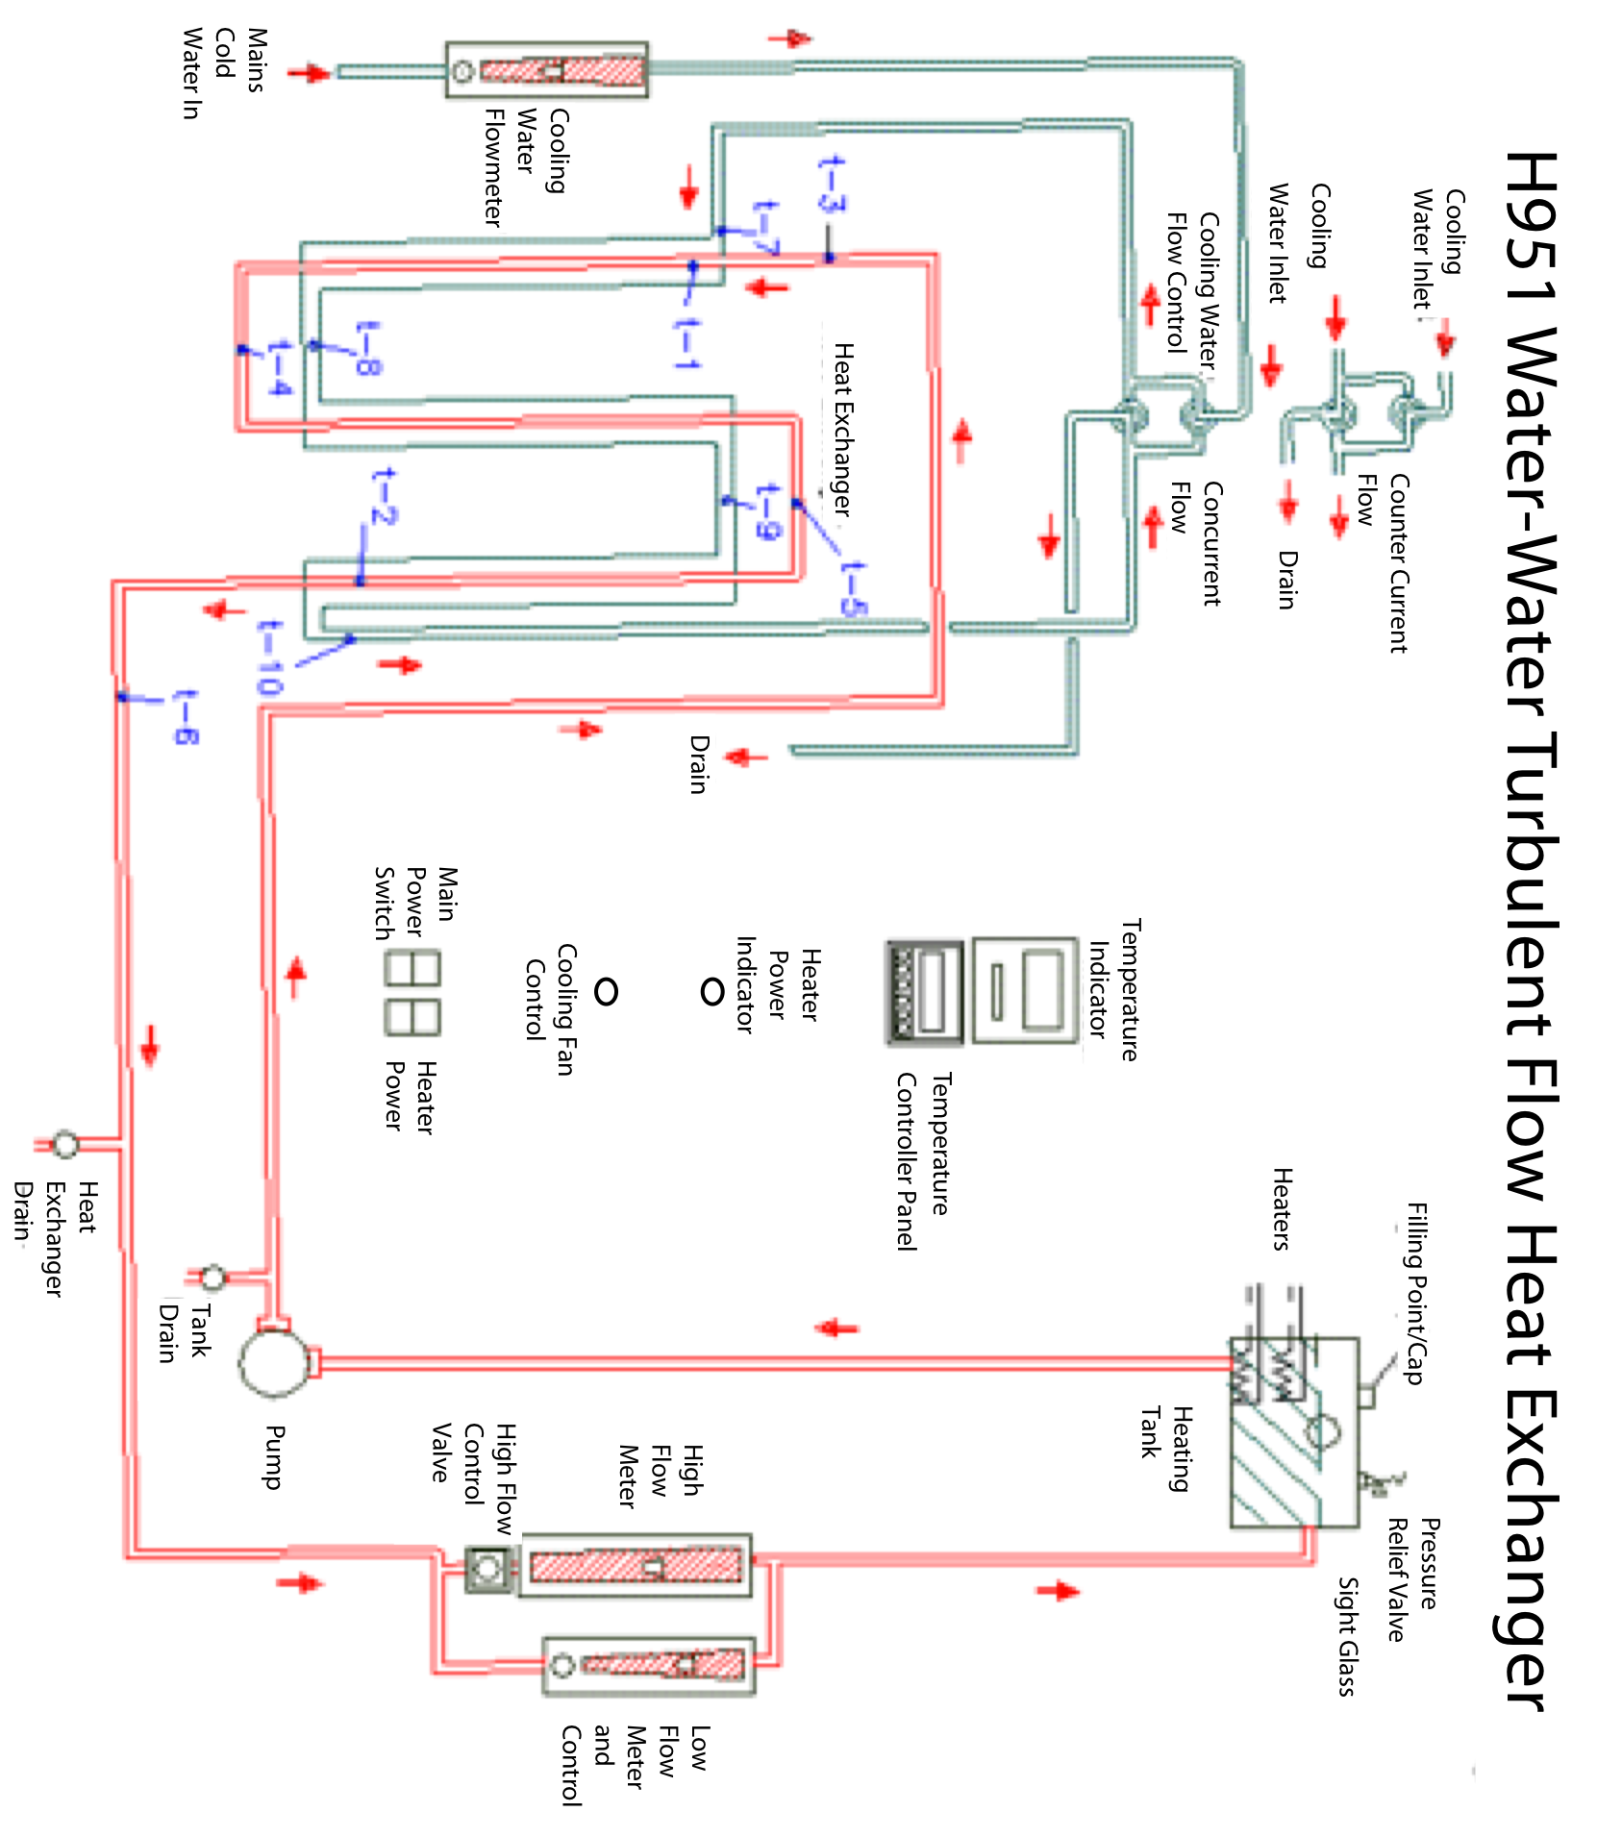
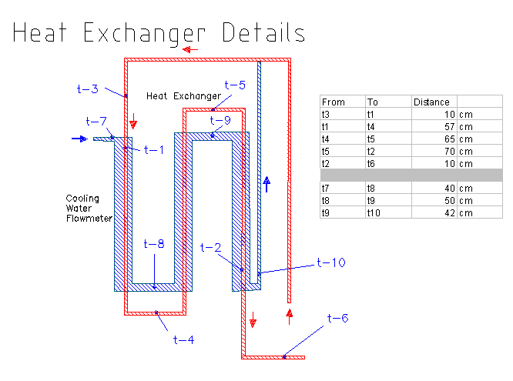
  - Thermocouple Measurement Points

- Metal wall on entry to first section of heat exchanger
- Metal wall on exit from third section of heat exchanger
- Hot stream entering first section of heat exchanger
- Hot stream between first and second section of heat exchanger
- Hot stream between second and third section of heat exchanger
- Hot stream leaving third section of heat exchanger
- Cold fluid entry/exit temperature
- Cold fluid temperature between first and second section of heat exchanger
- Cold fluid temperature between second and third section of heat exchanger
- Cold fluid entry/exit temperature

  - Heater Temperature Controller

The controller will keep the temperature within ±2°C. To change the heater temperature:
- Hit the SETPTS button repeatedly until you reach ‘SP3’; wait a few seconds for the temperature to appear
- Use the down arrow/min button to dial over to the proper digit
- Use the ^/max button to change the temperature
  - Heat Exchanger Dimensions

Core Tube Material = Copper
External Diameter (d_{o}) = 9.5 mm
Internal Diameter (d_{i}) = 7.9 mm
Length = 3 * 350 mm

Outer Tube Material = Copper
External Diameter = 12.7 mm
Internal Diameter = 11.1mm

- Laboratory Procedure

  - Part 1: Determination of heat transfer rate, logarithmic mean temperature difference and overall heat transfer coefficient.

- Set the cooling water flow control valves to counter-flow.
- Turn on the cooling water supply and open the cooling water flow control valve on the cooling water flow meter. Ensure that cooling water flows freely through the flow meter and heat exchanger to the drain.
- Check that the heater tank contains water to the correct level. Fill if necessary.
- Supply power to the unit by turning on the main switch only.
- Close the “low flow” control valve and open the “high flow” control valve to 10 l/min.
- Close cooling water flow control.
- Turn on the heater supply switch and set the temperature controller to a set point of 70ºC.
- Allow the unit to increase in temperature until the hot water temperature (t₃) is about 70° C.
- Adjust the cold water flow to 15 g/sec and wait until stable operating conditions are obtained. (t₃=70°C).
- Obtain temperature readings of t₁-t₁₀ and flow meter values as required in the table.

  - Part 2: Determination of surface heat transfer coefficient inside and outside the tube and the effect of fluid velocity on these and investigation of the relationship between Nusselt, Reynolds, and Prandtl numbers. NOTE: IF CONTINUING FROM PART 1, SKIP TO STEP 8.

- Set the cooling water flow control valves for counter-flow.
- Check that the heater tank contains water to the correct levels.
- Open the “high flow” water control valve (hot water) and set to 10 l/min.
- Switch on the mains.
- Set the heater controller to a set point of 70°C (t₃).
- Adjust the cold water to 15 g/sec.
- Allow conditions to stabilize.
- Make observations as indicated on data sheet (Note that the first column should be the same as your data for Part 1 and that there is an extra, unused, column in the table).
- Reduce the hot water flow rate to 7.5 l/min without changing the cold water flow rate or heater control.
- Allow conditions to stabilize at t₃ = 70ºC, and repeat observations as previously done.
- Repeat steps 9 and 10 with hot water flow rate of 5.0 l/min and 2.5 l/min.

  - Part 3: Comparison of parallel flow and counter-flow in a heat exchanger. NOTE: IF CONTINUING FROM PART 2, SKIP TO STEP 5.

- Set the cooling water flow control valves for counter-flow.
- Check that the heater tank contains water to the correct level.
- Fully open the “high flow” valve.
- Switch on the mains and heater controller, and raise the hot water temperature (t₃) to about 50°C.
- Close the hot water “high flow” valve and open the low hot water flow rate to 30 g/sec.
- Set the cold water flow rate to 20 g/sec.
- Allow the system to stabilize. Note: If you initially run both flow rates higher until t₃ is almost 50ºC, the system will equilibrate faster.
- Make the observations as instructed.
- Quickly reverse the position of the cooling water flow control valves to reverse the direction of the cooling water to parallel flow.
- If necessary, adjust the hot and cold water flow rates as closely as possible to the same values as in 5 and 6 above and allow the system to stabilize with t₃ = 50ºC.
Repeat the observations as made for counter-flow.

4. Required Calculations and Analysis

Be sure to include all of the following items in your report.

  - Part 1

- Find the heat transfer rate in Watts for both the hot and cold sides of the heat exchanger based on the change of temperature of each fluid. Compare the two results.
- Find the overall logarithmic mean temperature difference, ΔT_{lm}.
- Find the overall heat transfer coefficient, U, based on the outside area of the inner tube, A_{o}.
- Plot temperature as a function of distance from hot inlet for both the hot and cold flow.

  - Part 2

- Find the overall heat transfer coefficient for each case, based on A_{o}.
- Plot U as a function of hot mass flow rate.
- For each case, find the heat transfer coefficients h_{hot} and h_{cold} for the heat exchanger.
Hint: Using the LMTD method with the concept of thermal resistance, draw the thermal network at the entrance to the heat exchanger. Apply the thin-wall and steady state assumptions and solve for both the hot and cold flow.
- Using h_{hot} and h_{cold}, calculate the estimated overall heat transfer coefficient, U_{est}, and compare with the U calculated above.
- Plot U_{est}, h_{hot} and h_{cold} as a function of hot mass flow rate on the same graph as U.
- For the hot fluid, calculate the Nusselt number for each case, both directly and from the turbulent flow correlation (Nu_{est} = 0.023 Re^{0.8} Pr^{0.3}). [See Incropera & DeWitt equation # 8.60].
- Plot Nu and Nu_{est} as a function of Re. Discuss these results.

  - Part 3

- For both flow configurations, find the heat transfer rate in Watts for both the hot and cold sides of the heat exchanger. Compare the two results.
- Plot the temperature as a function of position from the hot inlet for the two configurations. Compare these results.
- For both configurations, find ΔT_{lm} and the overall heat transfer coefficient, U, based on the mean area.
- Find NTU and effectiveness, ε, for both configurations.
Using the temperature plots to help, explain the differences in the resulting effectiveness.

5. Lab Report Format

The purpose of the lab is not only to apply your understanding of heat transfer to a simple experiment but also to give you practice in communicating your findings. As such, the quality of the writing will be evaluated in terms of grammar, spelling, clarity, organization, and legibility of figures and tables. The report should be understandable by someone who is not necessarily familiar with the specifics of the lab. The quality of the writing will count for at least half of your grade.
Reports must be typed, double-spaced with suitable margins. Please use only one side of the page, normal white paper; forgo fancy covers. The following format is required for organization of the report:

- Title page
- Introduction
- Theory and Methods
- Results and analysis
- Part 1
- Part 2
- Part 3
- Discussion and Conclusions
- Appendices (e.g. data, sample calculations)

The Title page should include the title of the lab, the names of all members of the lab group, as well as the date on which the lab was performed. Please make this a separate page.
The Introduction section should briefly state what you are trying to do and why you are doing the experiment. Do not simply copy or paraphrase the appropriate sections of the lab handout.
The section on Theory and Methods should explain the relevant theory, measurement techniques, and procedures of the lab. Please be complete and sufficiently detailed for someone who has not performed the lab to be able to understand it. Derivations of equations used in your analysis are appropriate. Again, do not simply copy or paraphrase the appropriate sections of the lab handout.
In the Results and Analysis section, you should summarize and explain the results of the experiment, including charts and graphs. This section should be strictly factual, pointing out agreement and discrepancies between your results and those predicted by theory. All numerical results should be non-dimensional or reported in SI units. This is where most of the items you calculate and plot in section 4 should go.
For the Discussion and Conclusions, examine whether the lab satisfies the stated purpose, explaining what you have learned. Also postulate why any differences might have arisen between the theoretical (or standard experimental) values and your own results.
The Appendices should contain relevant information that is not in the body of the lab report, such as original data sheet and details of calculations made both in lab and as part of you data analysis. Sample calculations should either be typeset or neatly written in ink.
If you rely on information from textbooks or other references, cite the references in appropriate bibliographic style. Quoting references without citing sources is plagiarism.

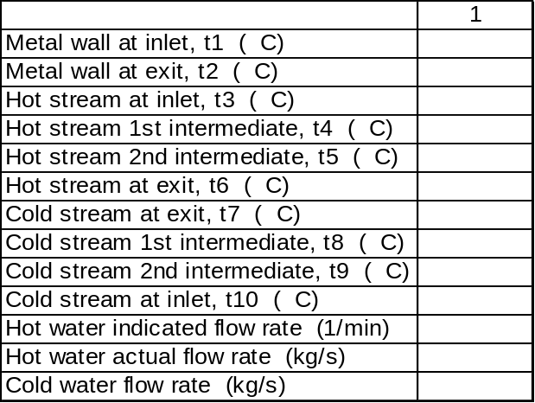Part 1 Data Sheet

Part 2 Data Sheet

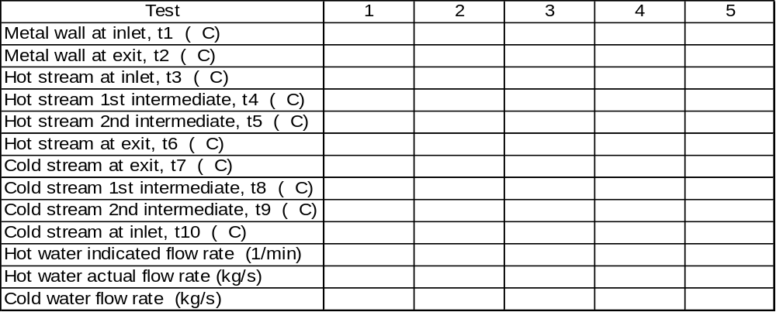

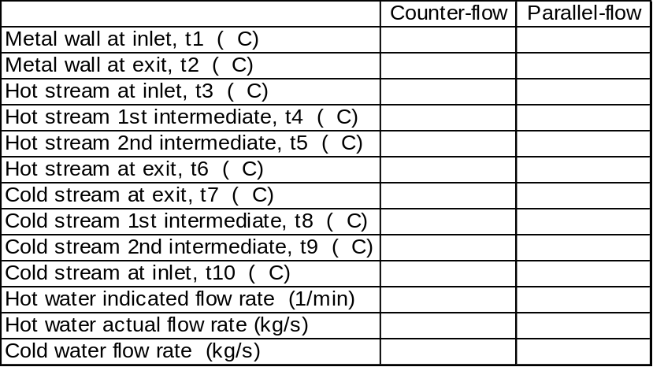Part 3 Data Sheet

Figures

